Lección: * Asking someone his/ her age.

* Saying how old you are

|  |  |
| --- | --- |
|  | MC900336122[1]  **¿Cuántos años tienes tú?**  *How old are you? (informal)* |
| **Yo tengo _____ años.**  *I am ____ years old.*  The question actually means How many years do you have? When you say “Yo tengo once años.”  you are really saying “I have 11 years.” Muy interesante, ¿verdad? |
|  |  |

**ACTIVIDAD:** Write how old each person is based on how many candles you count on their cake. Follow the example.

**Example:**

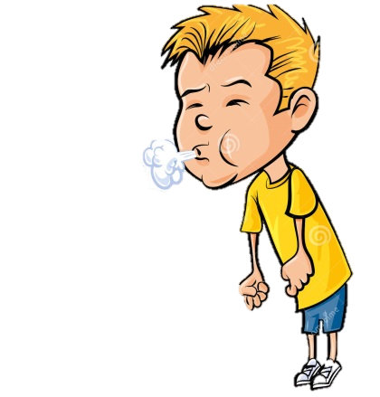**¿Cuántos años tienes tú?**

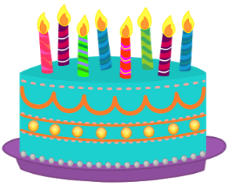 Yo tengo ocho años.

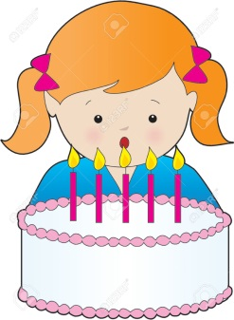

¿Cuántos años tienes tú?

______________________________________________________________